PRACTICAL 6

What if analysis:

STEPS:

1. Create a sample data in excel as shown-

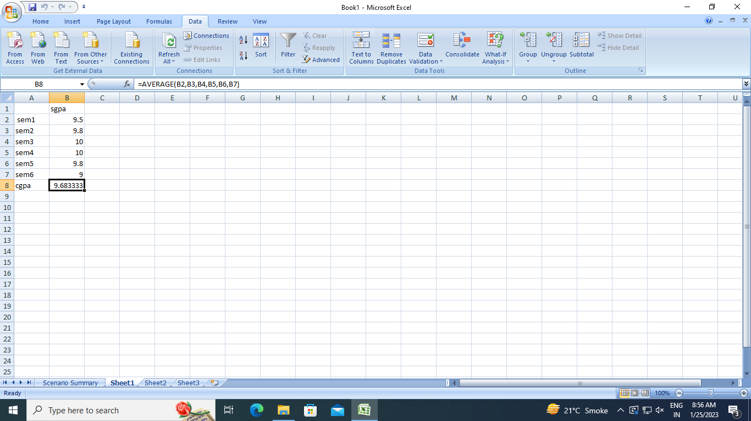

1. Click on data tab and in data tools section click on what-if analysis
2. Click on scenario manager and a dialogue box appears.
3. Add a new scenario by clicking on add a new box appears.
4. Give a name for the scenario and mention the cell on which changes needs to be done and click ok.
5. Enter the value for the changing cell and click on ok.
6. In the same manner we can add the rest of the scenarios.
7. After all the scenario has been added then select the summary option.
8. Then a new sheet has been created which consist the output of the what-if analysis.
9. The output is as shown below:

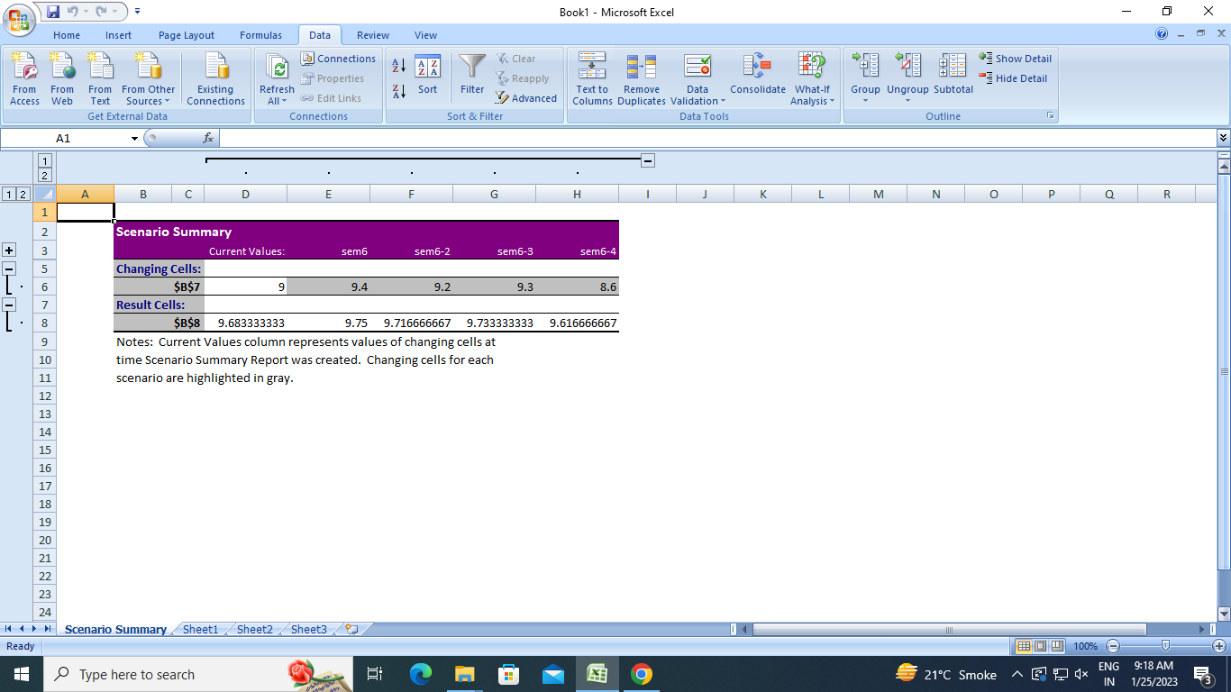

PRACTICAL 5

1. Import the Datawarehouse data in Microsoft Excel and create the Pivot table and Pivot Chart.

STEPS:

1. Open the excel file in which the data is stored as shown-

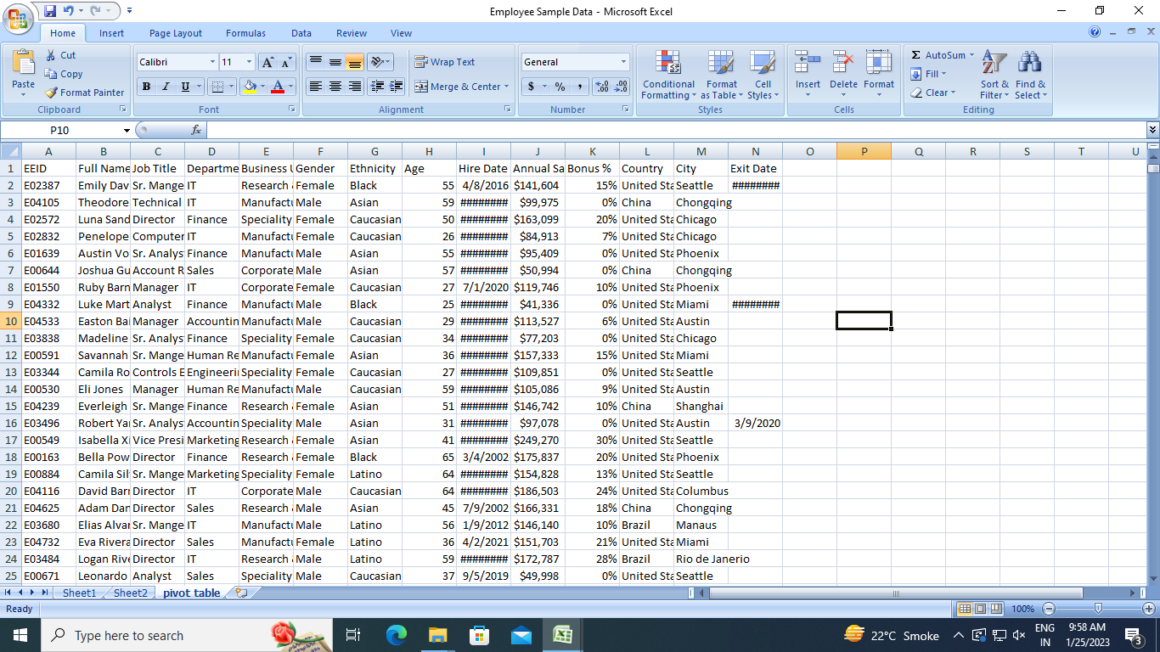

To create a pivot table in excel:

1. In the insert column select the pivot table option.
2. Create pivot table window appears.
3. Select the table or the range of data that you want to create a pivot table of.
4. And click ok
5. A new option for occurs i.e. pivot table fields.
6. Select the fields that you want to add your pivot table.
7. The pivot table occurs on selection of the columns as shown-

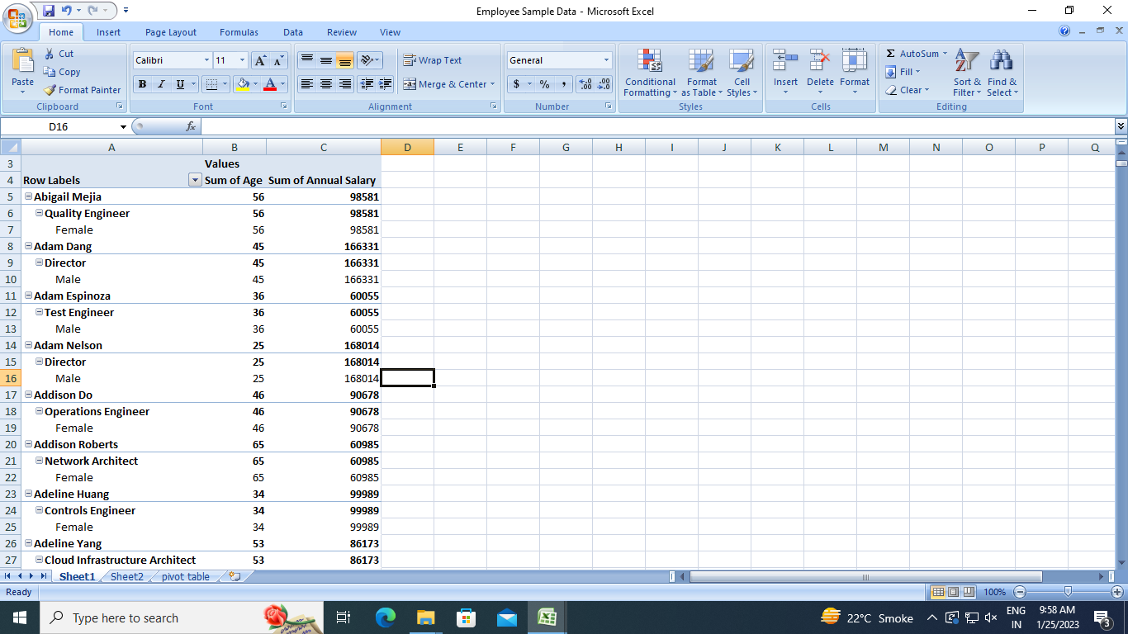

To create a pivot chart in excel:

1. In the insert column select the pivot chart option.
2. Create pivot chart window appears.
3. Select the table or the range of data that you want to create a pivot table of.
4. And click ok
5. A new option for occurs i.e. pivot table fields.
6. Select the fields that you want to add your pivot chart.
7. The pivot chart occurs on selection of the columns as shown-

